GLYCATION AFFECTS DIFFERENTLY THE MAIN SOYBEAN BOWMAN-BIRK ISOINHIBITORS, IBB1 AND IBBD2, ALTERING THEIR ANTIPROLIFERATIVE PROPERTIES AGAINST COLON CANCER CELLS
Raquel Olíasª, Carmen Becerra-Rodríguezª, Jorge R. Soliz-Ruedaª, F. Javier Moreno^{b}, Cristina Delgado-Andradeª and Alfonso Clemente ^{a*}
ªEstación Experimental del Zaidín (EEZ, CSIC), Profesor Albareda 1, Granada 18008, Spain. ^{b}Institute of Food Science Research (CIAL, CSIC), Nicolás Cabrera 9, Madrid 28049, Spain.
* Presenting author: alfonso.clemente@eez.csic.es
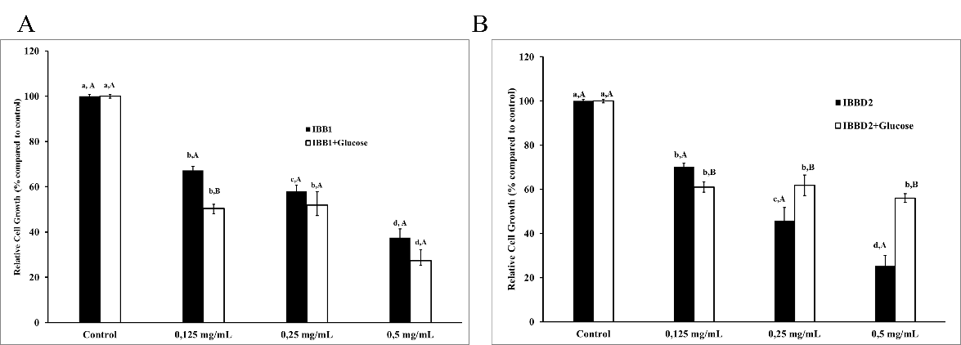
Naturally-occurring serine protease inhibitors of the Bowman-Birk (BBI) family exert their potential chemopreventive and/or therapeutic properties via protease inhibition. Processing of soybeans for human consumption has been proposed as responsible for the loss of positive bioactivity due to the glycation of the proteins during this process. The aim of this work was to understand the effects of glycation of the two major BBI isoinhibitors from soybean, IBB1 and IBBD2, on their functional properties measured as trypsin and chymotrypsin inhibitory activity and antiproliferative effect on HT29 human colorectal adenocarcinoma cells. Proteins react with reducing sugars at lysine and arginine residues in early stages of the maillard reaction. In soybean BBI isoinhibitors, IBB1 and IBB2, lysine and arginine are key residues in their inhibitory domains. Soybean BBI were purified and subjected to glycation using glucose at high temperature. Glycation pattern of both soybean BBI isoinhibitors was analysed by MALDI-TOF spectrometry and the peptides obtained were analyzed in silico. Both isoinhibitors showed remarkable heat stability. IBB1 maintained 100% of its inhibitory activity after 90 minutes at 95 °C, losing only 25% of its trypsin inhibitory activity after 120 minutes of heat treatment. IBBD2 was less thermostable and after 120 minutes at 95 °C its activity was less than 50% of the control. In the presence of glucose, IBBD2 lost most of its inhibitory activity while IBB1 maintain the same activity as in absence of sugar. Glycation of both isoinhibitors was confirmed by MALDI-TOF spectrometry since glucose adducts were identified. In an attempt to identify the glycated amino-acid residues, the peptides obtained by MALDI-TOF-TOF were analyzed in silico using the program FindPept, a software tool that identifies masses resulting from unspecific proteolytic cleavage normally happening in glycated samples. Apparently the lysines residues responsible for the trypsin inhibitory activity of IBB1 are less prone to be glycated than the arginine resides in the inhibitory domains of IBB2. Previous studies in our group have proven the capacity of BBI to inhibit the growth of human colon cancer cells HT29 in a dose-dependent manner (Clemente et al., 2010). As a result of the differential glycation process, the anti-proliferative properties of IBBD2 against HT29 colon cancer cells were significantly diminished whereas IBB1 was unaffected (Figure) (Olias et al., 2019).
Figure. Effects of glycation over the anti-proliferative effect of BBI isoinhibitors, IBB1 and IBBD2, on the in vitro growth of HT29 human colorectal adenocarcinoma cells. IBB1 and IBBD2 were previously heated for 90 minutes in the presence or absence of glucose. Controls have no inhibitor and cell viability was considered 100%. (A) Percentage of cell growth treated with IBB1 (closed bars) and glycated IBB1 (open bars). (B) Percentage of cell growth treated with IBBD2 (closed bars) and glycated IBBD2 (open bars). Growth media were supplemented with protein in the concentration range 0–61 mM and cells harvested after a period of 96 h. Values are means of at least three independent experiments with five technical replicates, bars represent standard deviations. Mean values with different letters were significantly different (P <0.05; Bonferroni’s test). Lower case letters are used to compare relative cell growth with different concentrations of protease inhibitor; uppercase letters are used to compare relative cell growth after treatment with glycated and non-glycated protease inhibitors.
References
Clemente, A., Moreno, J., Marin-Manzano, M.C., Jimenez, E., Domoney, C., 2010. The cytotoxic effect of Bowman-Birk isoinhibitors, IBB1 and IBBD2, from soybean (Glycine max) on HT29 human colorectal cancer cells is related to their intrinsic ability to inhibit serine proteases. Mol. Nutr. Food Res. 54, 396-405. https://doi.org/10.1002/mnfr.200900122.
Olias, R., Becerra, C., Soliz, J., Moreno, F.J., Delgado-Andrade, C., Clemente, A. 2019. Glycation affects differently the main soybean Bowman-Birk inhibitors, IBB1 and IBBD2, altering their ani-proliferative properties against HT29 colon cancer cells. Food Funct. 10, 6193-6202. https://doi.org/10.1039/C9FO01421G

